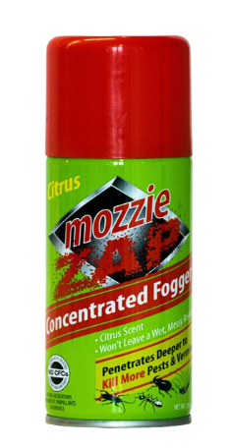
Mozzie Zap
Concentrated Fogger
Net Weight: 101 ml

Eliminates Aedes Mosquitoes

Effective against: Insects- mosquitoes, cockroaches, bed bugs, ants and fleas

Penetrates deeper to kill by paralyse and kill rats.

- 2-in-1 action
- Contains no CFCs
- No ozone depleting substances
- Safe and easy to use

Product Description

Mozzie Zap Concentrated Fogger is an eliminator.
With its “flushing” action, Aedes Mosquitoes which transmit dengue are effectively eliminated.

Mozzie Zap Concentrated Fogger’s 2-in-1 action kills insects on contact and has a residual effect that repels insects for added protection for households

It contains 1.7% Cypermethrin, a WHO approved active ingredient (OMS 2002)

Working Principle

- Cypermethrin is a chemical that will kill many insects including mosquitoes, bed bug, ants, flea and cockroaches. Cypermethrin is a broad-spectrum insecticide. It works as a potent, fast-acting neurotoxin against many types of insects. When an insect comes into contact with cypermethrin or ingests it as an aerosol, the compound rapidly get to work, interfering with nerve signalling in the insect’s body leading to paralysis. Once paralysed, the insect cannot perform its usual biological function and ultimately dies. It can remain active on surfaces for as long as 90 days so there is no need to reapply frequently. By spraying cypermethrin over cracks and crevices will ensure that any insects trying to use them as entry points will soon die.
- Cypermethrin is non-toxic to humans and pets. It is safe to use both indoor and outdoor... However, it is toxic to fish and aquatic animals
Recommended usage instructions
Prior to usage as fogger
- Close all windows
- Cover all food and utensils
- Remove pets, cover ponds and fish tanks
- No persons must be in within the premises
- Place coverings e.g old newspaper at the spot intended to place the Mozzie Zap Fogger

Step 1
- After the above actions have been adhered to, place the aerosol can on the laid out coverings.

- Choose a location to activate the Mozzie Zap Fogger further inside in the premises first, followed by the one nearest to the exit

Step 2
- Activate the cans by pressing the release valve right down until you hear a click sound.
- The aerosol can will then commence upward fogging
- After activating the cans, exit and lock-up the premises

Step 3
- Wait for 2 hours before re-entering the house and air the premises by opening up all the windows.
- The empty cans can then be recycled.
Manufactured for distribution:
Trojan Hospitality Asia Pte Ltd
33 Kaki Bukit Road 2
Singapore 417854
Tel: +65 6746 766
Prior to use as a sprayer
Step 1: Gently press the release valve, it will activate as a sprayer and content will spray like any aerosol mosquitos sprayer
Step 2: Gently release the valve , it will revert back to the original position
To use as a fogger , please see the above instruction carefully

