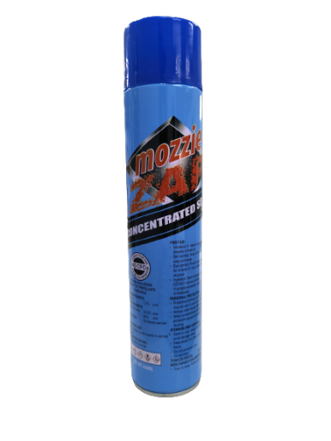
Mozzie Zap
Concentrated Sprayer
Net Weight: 600 ml

Eliminates Aedes Mosquitos

Effective against: Insects- mosquitoes, cockroaches, bed bugs,ants, fleas.

Penetrates deeper to kill by paralyse and kill rats.

- Contains no CFCs
- No ozone depleting substances
- Safe and easy to use

Product Description

Mozzie Zap Concentrated Sprayer is a broad-spectrum insecticide
With its action, Aedes Mosquitoes which transmit dengue are effectively eliminated.

Mozzie Zap Concentrated Sprayer kills insects and has a residual effect that repels insects for added protection for households.

It contains 1.7% Cypermethrin, a WHO approved active ingredient (OMS 2002)

Working Principle

- Cypermethrin is a chemical that will kill many insects including mosquitoes, bed bug, ants, flea and cockroaches. Cypermethrin is a broad-spectrum insecticide. It works as a potent, fast-acting neurotoxin against many types of insects. When an insect comes into contact with cypermethrin or ingests it as an aerosol, the compound rapidly get to work, interfering with nerve signalling in the insect’s body leading to paralysis. Once paralysed, the insect cannot perform its usual biological function and ultimately dies. It can remain active on surfaces for as long as 90 days so there is no need to reapply frequently. By spraying cypermethrin over cracks and crevices will ensure that any insects trying to use them as entry points will soon die.

- Cypermethrin is non-toxic to humans and pets. It is safe to use both indoor and outdoor... However, it is toxic to fish and aquatic animals

- Dual Operating Function:
- To use as a sprayer - Gently press the nozzle down without locking. A stream of continuous flow of mist will follow.
- To use as a Fogger- Press the nozzle all the way and locked. A stream of upward continuous flow of mist will follow.
Manufactured for distribution:
Trojan Hospitality Asia Pte Ltd
33 Kaki Bukit Road 2
Singapore 417854
Tel: +65 6746 766

